Name : Jay Keluskar
Roll:24102C0086 TE CMPN-C Ewaste Asgn-3

Automated Laser-Assisted Pyrometallurgical Recovery of Metals from Waste PCBs
Class: To be determined based on the applicable design classification.
Figure 1: The Perspective View
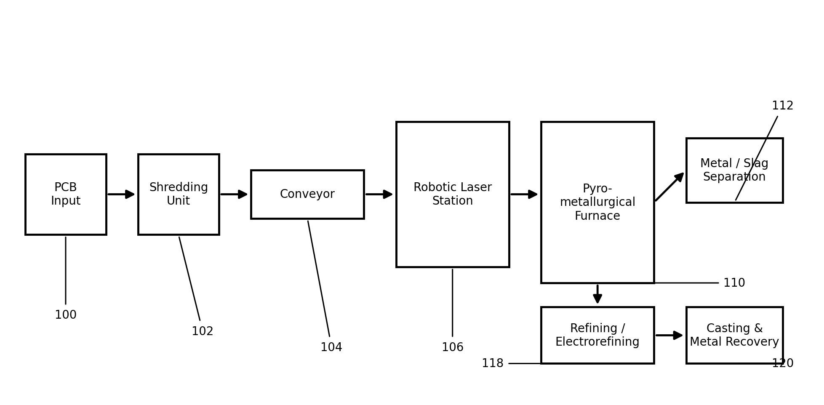
Figure 1 illustrates the perspective view of the automated laser-assisted pyrometallurgical recovery system. The system integrates a sequence of automated stations through which waste printed circuit boards (PCBs) are processed to recover valuable metals. Collected PCBs (100) are fed into a shredding unit (102) that reduces them into smaller, relatively uniform pieces, which are then carried by a conveyor (104) to a vision-guided robotic laser station (106) where solder, mounted components, and other unwanted material are selectively targeted and removed prior to high-temperature processing. The laser-treated material then passes into a pyrometallurgical furnace (110) where it is melted, allowing the metal fraction to separate from the non-metallic slag (112) on the basis of density. The separated metal is subsequently refined (118) and cast into ingots or pellets (120) for reuse.
[Inventor 1] [Inventor 2] [Inventor 3] [Inventor 4] [Inventor 5]

Automated Laser-Assisted Pyrometallurgical Recovery of Metals from Waste PCBs
Class: To be determined based on the applicable design classification.
Figure 2: The Side View
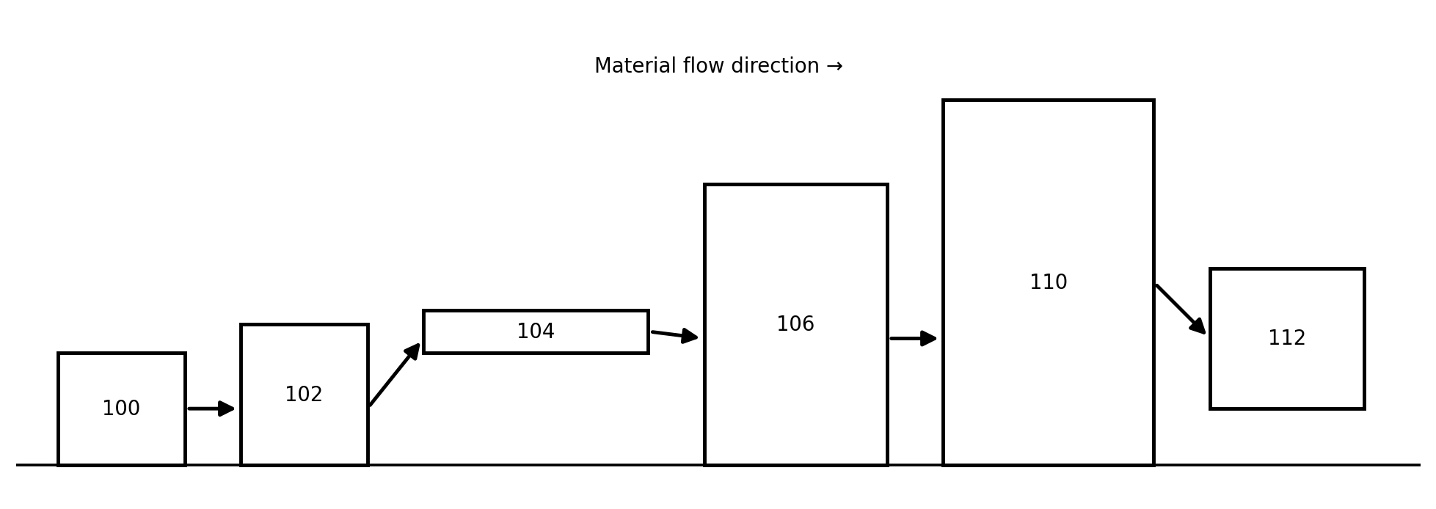
As shown in Figure 2, the side view illustrates the physical arrangement and relative elevation of the main equipment along the processing line, and the direction of material flow from left to right. The PCB input station (100) and shredding unit (102) are positioned at the start of the line, feeding shredded material onto the conveyor (104), which carries it up to the level of the robotic laser pre-treatment station (106). The pre-treated material then descends into the taller pyrometallurgical furnace (110) for smelting, after which the molten metal and slag fractions are drawn off into the separation section (112) positioned below and adjacent to the furnace outlet.
[Inventor 1] [Inventor 2] [Inventor 3] [Inventor 4] [Inventor 5]

Automated Laser-Assisted Pyrometallurgical Recovery of Metals from Waste PCBs
Class: To be determined based on the applicable design classification.
Figure 3: The Top View
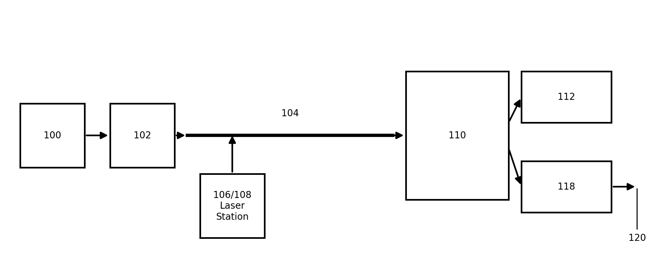
Figure 3 illustrates the top view of the system, showing the plan layout of the conveyor (104) and the position of the robotic laser station (106/108) alongside it, from where the vision-guided laser selectively treats the PCB pieces as they pass beneath. The conveyor delivers the pre-treated material to the feed side of the furnace (110), from which the separated metal stream is directed to the metal/slag separation and refining section (112/118), and finally to the metal recovery and casting outlet (120).
[Inventor 1] [Inventor 2] [Inventor 3] [Inventor 4] [Inventor 5]

Automated Laser-Assisted Pyrometallurgical Recovery of Metals from Waste PCBs
Class: To be determined based on the applicable design classification.
Figure 4: The Laser Pre-treatment Unit
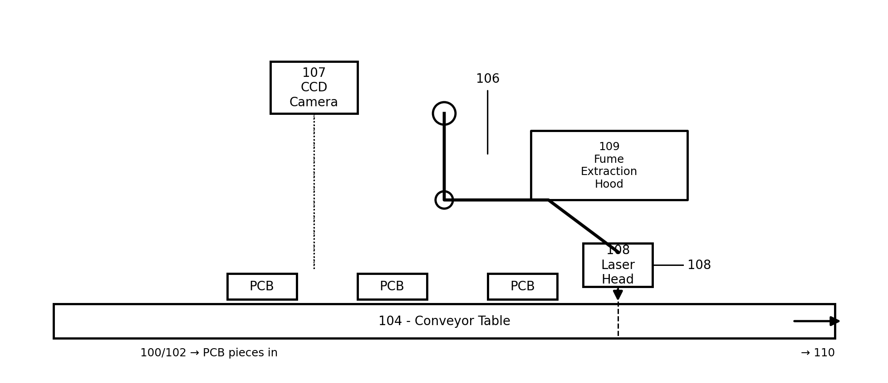
Figure 4 illustrates a detailed view of the automated laser pre-treatment unit, which forms the central novel feature of the proposed system. Shredded PCB pieces arriving from the collection and shredding stage (100/102) travel along the conveyor table (104) beneath a CCD vision camera (107), which identifies the location of solder, mounted components, and other targeted material on each piece. Guided by this vision data, the robotic manipulator (106) positions the laser head (108) to selectively irradiate and remove the targeted material, while a fume extraction hood (109) positioned above the treatment zone draws away the resulting fumes and particulate matter. The pre-treated PCB material then continues along the conveyor toward the pyrometallurgical furnace (110) for smelting.
[Inventor 1] [Inventor 2] [Inventor 3] [Inventor 4] [Inventor 5]

Automated Laser-Assisted Pyrometallurgical Recovery of Metals from Waste PCBs
Class: To be determined based on the applicable design classification.
Figure 5: The Smelting, Separation & Recovery Unit
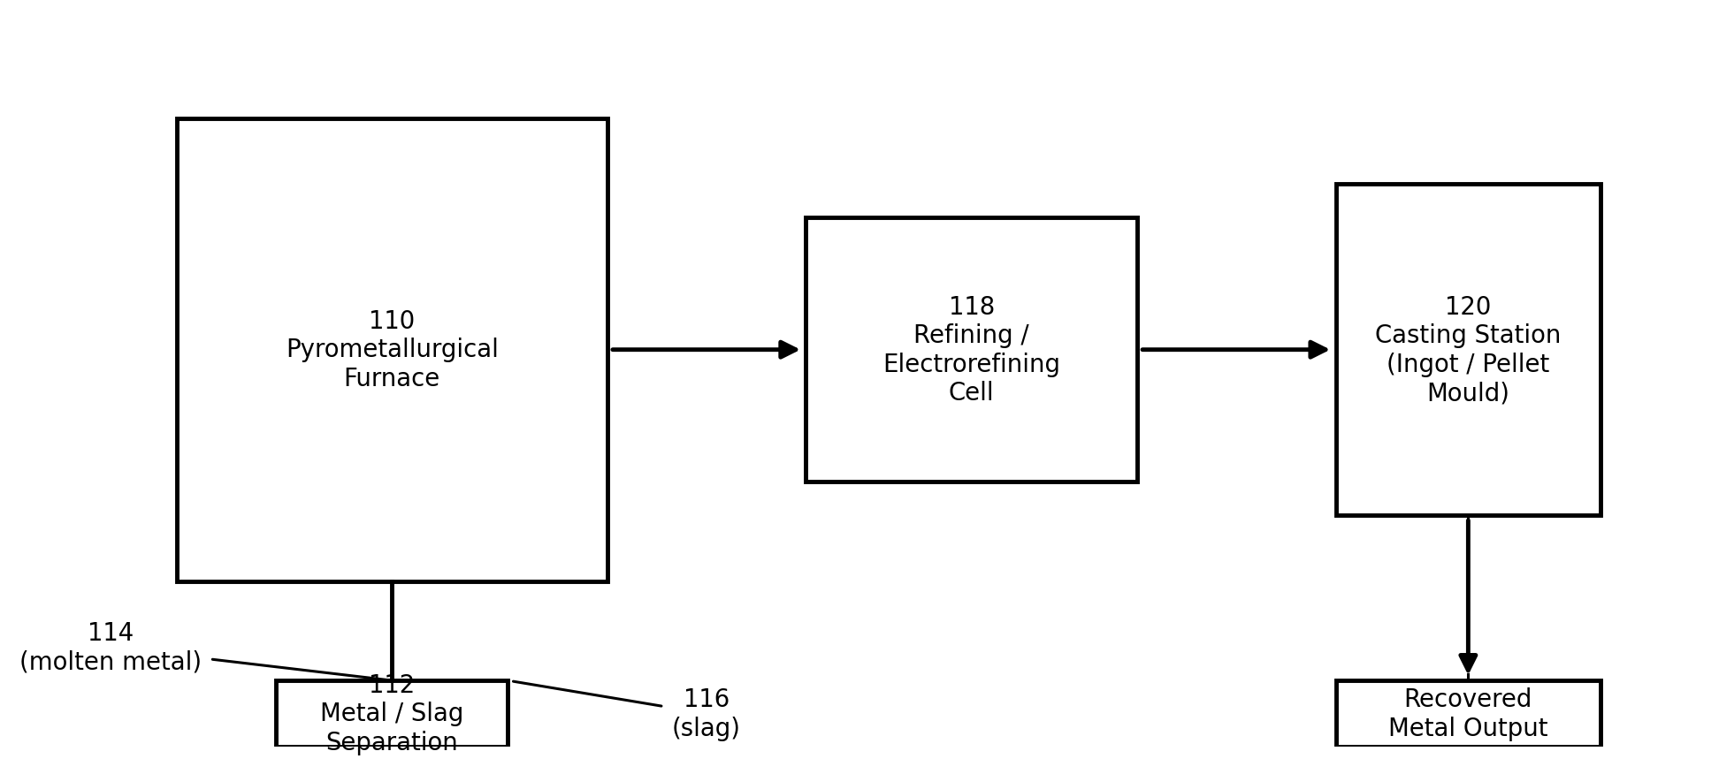
Figure 5 illustrates the smelting, separation, and recovery unit that receives the laser pre-treated PCB material. The pyrometallurgical furnace (110) melts the incoming material at high temperature, causing the metal fraction to separate from the non-metallic slag fraction on the basis of density in the metal/slag separation section (112), which yields a molten metal stream (114) and a separate slag stream (116). The molten metal is directed to a refining and electrorefining cell (118) to obtain high-purity metal, which is then transferred to the casting station (120) where it is cast into ingots, pellets, or other reusable forms as the final recovered metal output.
To the best of our knowledge and belief, the proposed system and its specific combination of automated laser-assisted pre-treatment, pyrometallurgical processing, metal-slag separation, and refining have been developed as an integrated approach for recovering valuable metals from waste PCBs. The novelty of this proposal lies specifically in the integration of a vision-guided robotic laser pre-treatment stage ahead of the pyrometallurgical smelting stage, rather than in the underlying practice of PCB recycling itself, which is a known field.
[Inventor 1] [Inventor 2] [Inventor 3] [Inventor 4] [Inventor 5]

